**DAILY ONLINE ACTIVITIES SUMMARY**

|  |  |  |  |  |  |  |  |
| --- | --- | --- | --- | --- | --- | --- | --- |
| **Date:** | **13/06/2020** | | | | **Name:** | **Churashma** | |
| **Sem & Sec** | **4th SEM 'A' Section** | | | | **USN:** | **4AL18CS019** | |
| **Online Test Summary** | | | | | | | |
| **Subject** | | **Data communication** | | | | | |
| **Max. Marks** | | **30** | | **Score** | | **28** | |
| **Certification Course Summary** | | | | | | | |
| **Course** | **Introduction to neural networks and deep learning.** | | | | | | |
| **Certificate Provider** | | | **greatlearning academy** | **Duration** | | | **9.5 hours** |
| **Coding Challenges** | | | | | | | |
| **Problem statement 1: Write a C Program to calculate Electricity Bill.**  **Problem statement 2:How to find the first non repeated character of a given String? Using java .** | | | | | | | |
| **Status: completed** | | | | | | | |
| **Uploaded the report in Github** | | | | **yes** | | | |
| **If yes Repository name** | | | | **https://github.com/Churashma/Lockdown-coding** | | | |
| **Uploaded the report in slack** | | | | **yes** | | | |

ONLINE TEST DETAILS: DC test was scheduled from 02:00 pm to 02:30 pm .The portion for the IA was 1 and 2 module there were 30 questions and the time assigned was 30 minutes the questions were mcq type.

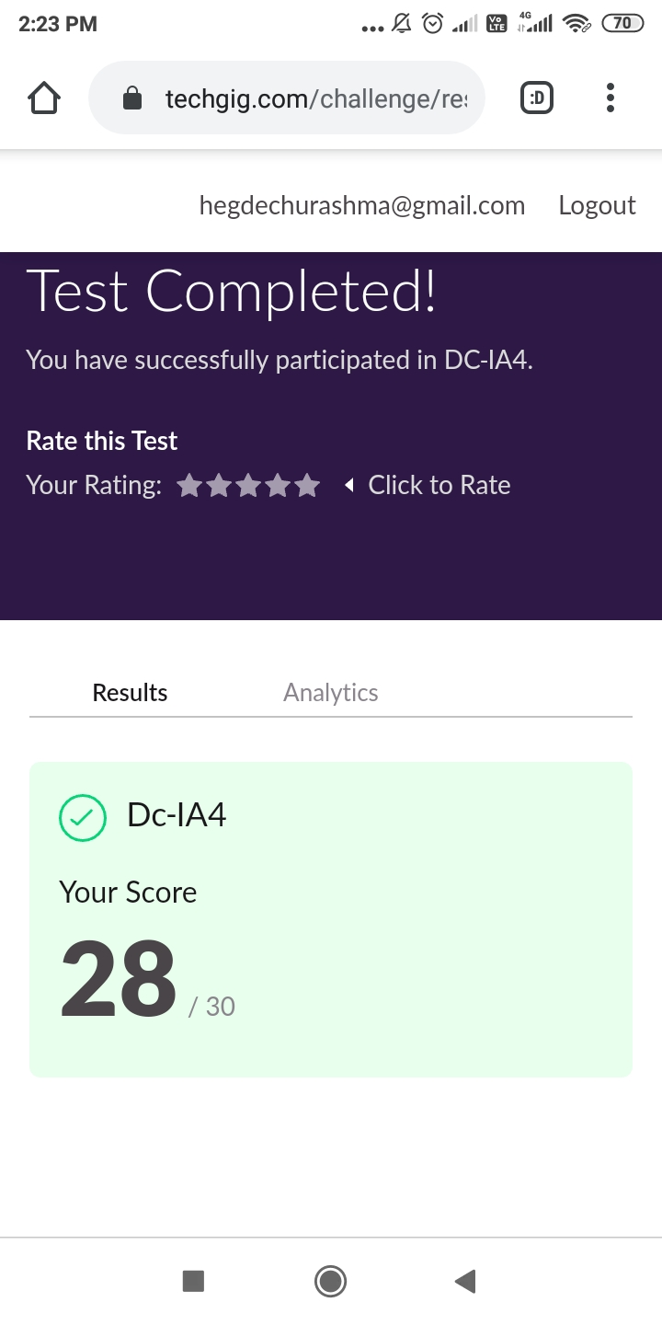

CERTIFICATION COURSE DETAILS: Today I studied about learning rate setting and tuning and also I studied about building a neural network from scratch.The amount that the weights are updated during training is referred to as the step size or the “learning rate.” Specifically, the learning rate is a configurable hyperparameter used in the training of neural networks that has a small positive value, often in the range between 0.0 and 1.0.

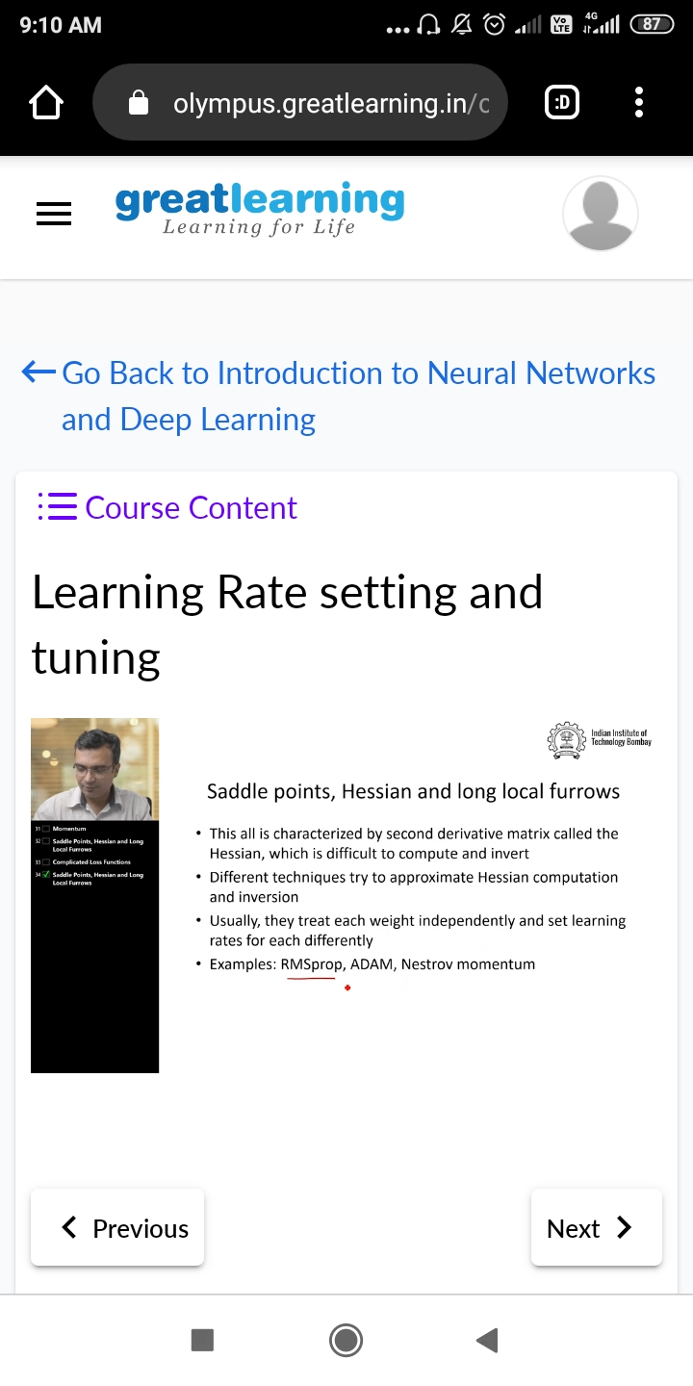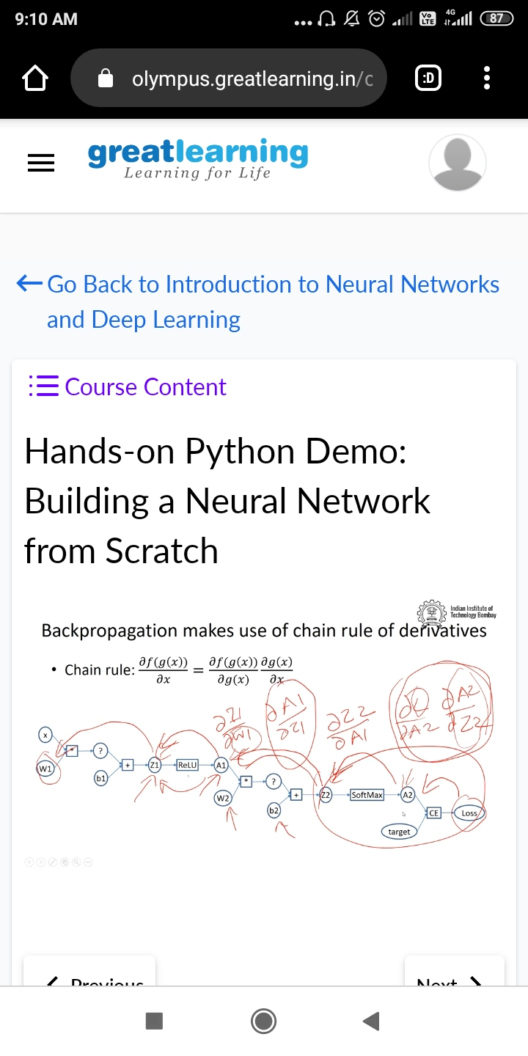

**CODING CHALLENGES DETAILS**:

**Problem statement 1: Write a C Program to calculate Electricity Bill.**

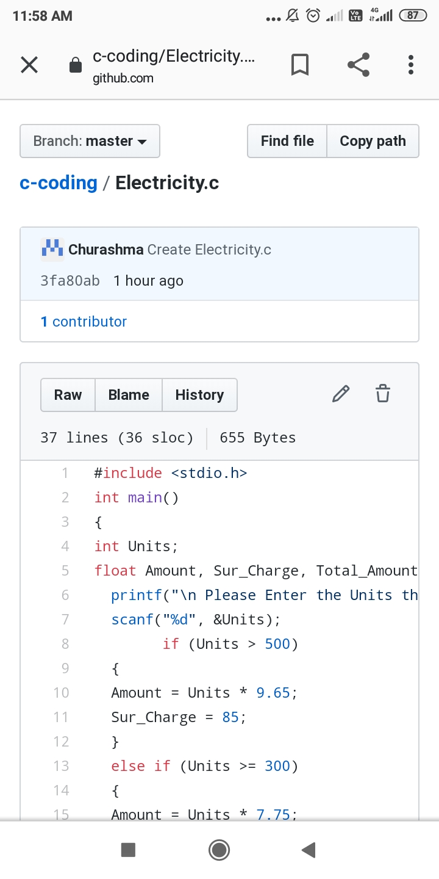

Problem statement 2: How to find the first non repeated character of a given String? Using java .

